create database bank;

use bank;

create table branch (

branch_name varchar(25),

branch_city varchar(15),

assets int,

primary key (branch_name)

);

create table bank_account (

accno int,

branch_name varchar(25),

balance int,

primary key (accno),

foreign key (branch_name) references branch(branch_name)

);

create table bank_customer (

customer_name varchar(10),

customer_street varchar(25),

customer_city varchar(15),

primary key (customer_name)

);

create table depositer (

customer_name varchar(10),

accno int,

primary key(customer_name, accno),

foreign key (customer_name) references bank_customer(customer_name),

foreign key (accno) references bank_account(accno)

);

create table loan (

loan_number int,

branch_name varchar(25),

amount int,

primary key (loan_number),

foreign key (branch_name) references branch(branch_name)

);

insert into branch values('SBI_Chamrajpet', 'Bangalore', 50000);

insert into branch values('SBI_ResidencyRoad', 'Bangalore', 10000);

insert into branch values('SBI_ShivajiRoad', 'Bombay', 20000);

insert into branch values('SBI_ParliamentRoad', 'Delhi', 10000);

insert into branch values('SBI_Jantarmantar', 'Delhi', 20000);

commit;

insert into bank_account values(1, 'SBI_Chamrajpet', 2000);

insert into bank_account values(2, 'SBI_ResidencyRoad', 5000);

insert into bank_account values(3, 'SBI_ShivajiRoad', 6000);

insert into bank_account values(4, 'SBI_ParliamentRoad', 9000);

insert into bank_account values(5, 'SBI_Jantarmantar', 8000);

insert into bank_account values(6, 'SBI_ShivajiRoad', 4000);

insert into bank_account values(8, 'SBI_ResidencyRoad', 4000);

insert into bank_account values(9, 'SBI_ParliamentRoad', 3000);

insert into bank_account values(10, 'SBI_ResidencyRoad', 5000);

insert into bank_account values(11, 'SBI_Jantarmantar', 2000);

commit;

insert into bank_customer values ('Avinash', 'Bull_Temple_Road', 'Bangalore');

insert into bank_customer values ('Dinesh', 'Bannergatta_Road', 'Bangalore');

insert into bank_customer values ('Mohan', 'National_College_Road', 'Bangalore');

insert into bank_customer values ('Nikhil', 'Akbar_Road', 'Delhi');

insert into bank_customer values ('Ravi', 'Prithviraj_Road', 'Delhi');

commit;

insert into depositer values('Avinash', 1);

insert into depositer values('Dinesh', 2);

insert into depositer values('Nikhil', 4);

insert into depositer values('Ravi', 5);

insert into depositer values('Avinash', 8);

insert into depositer values('Nikhil', 9);

insert into depositer values('Dinesh', 10);

insert into depositer values('Nikhil', 11);

commit;

insert into loan values(1, 'SBI_Chamrajpet', 1000);

insert into loan values(2, 'SBI_ResidencyRoad', 2000);

insert into loan values(3, 'SBI_ShivajiRoad', 3000);

insert into loan values(4, 'SBI_ParliamentRoad', 4000);

insert into loan values(5, 'SBI_Jantarmantar', 5000);

commit;

select * from branch;

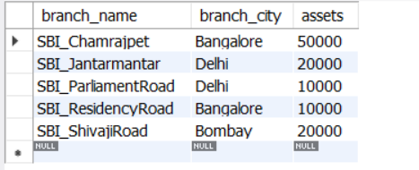

select * from bank_account;

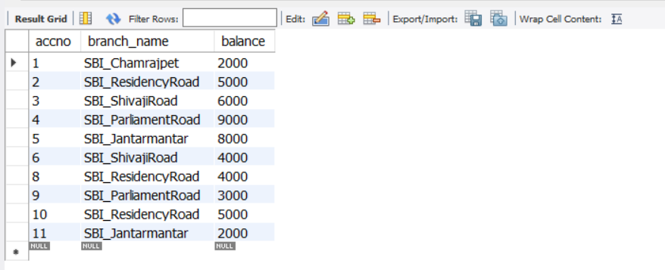

select * from bank_customer;

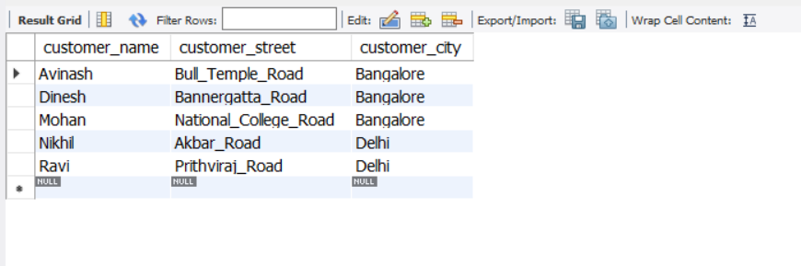

select * from depositer;

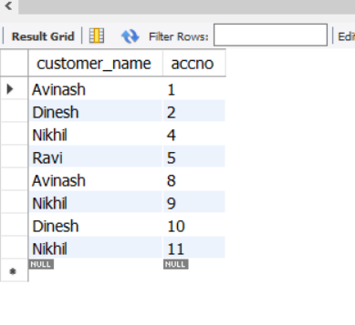

select * from loan;

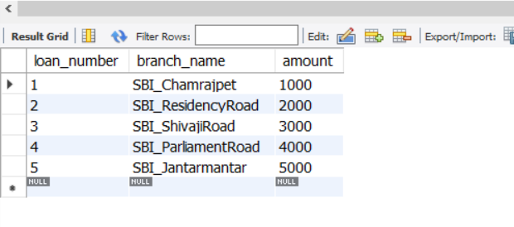

-- Query 3

select distinct c.customer_name from bank_customer c,bank_account b where exists(select d.customer_name,count(d.customer_name) from depositer d,bank_account ba where ba.accno = d.accno and

c.customer_name = d.customer_name and ba.branch_name = 'SBI_ResidencyRoad' group by d.customer_name having count(d.customer_name)>=2);

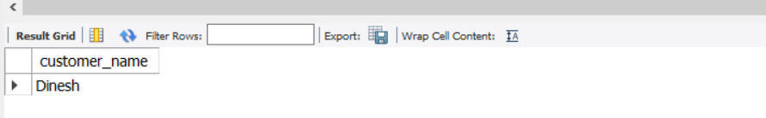

-- Query 4

select d.customer_name from depositer d,branch b,bank_account a

where b.branch_name=a.branch_name

AND a.accno=d.accno

and branch_city='Delhi'

group by d.customer_name

HAVING COUNT(distinct b.branch_name)=(

SELECT COUNT(branch_name)

FROM branch

WHERE branch_city='Delhi');

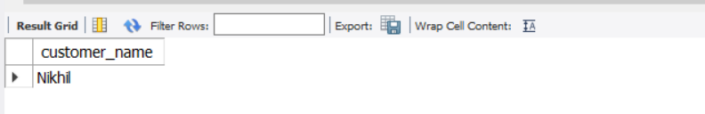

-- Query 5

delete from bank_account where branch_name in (select branch_name from branch where branch_city = 'Bombay');

select * from bank_account;

